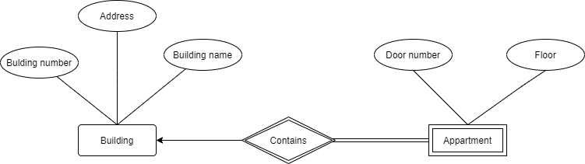

Building – Strong entity

Appatrment- Weak entity

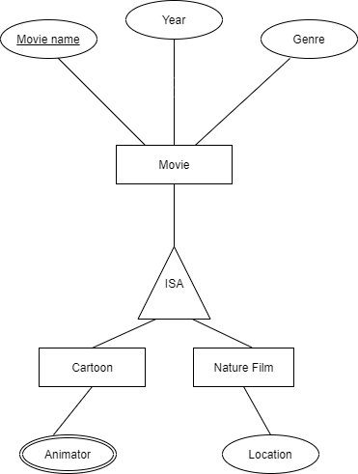

Movie-super type

Cartoon-sub type

Nature Film – sub type

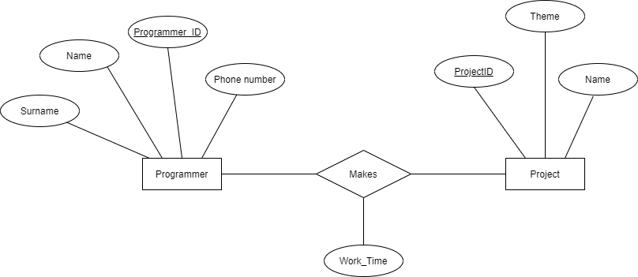

Programmer- Strong entity

Project – Strong entity

Work_Time-all

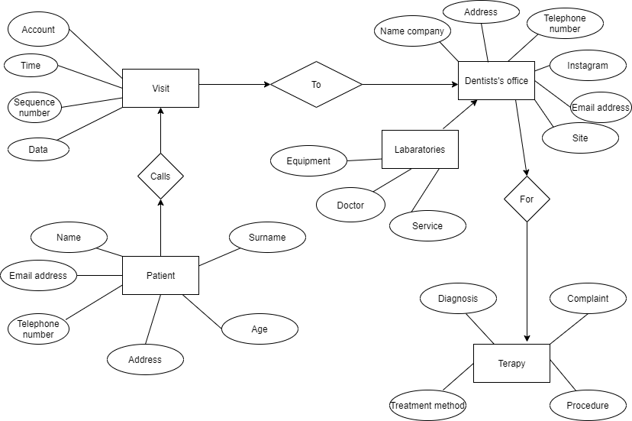

Dentists office- Super type

Visit

